Hands – On Lab Workshop 2

*Note: It is mandatory for all students to draw the diagram in drawing tools as well as in a A4 paper describing the flow of each diagram in a paragraph.*

# Activity Diagram

* 1. Using an activity diagram, describe the process of student enrollment in an University.

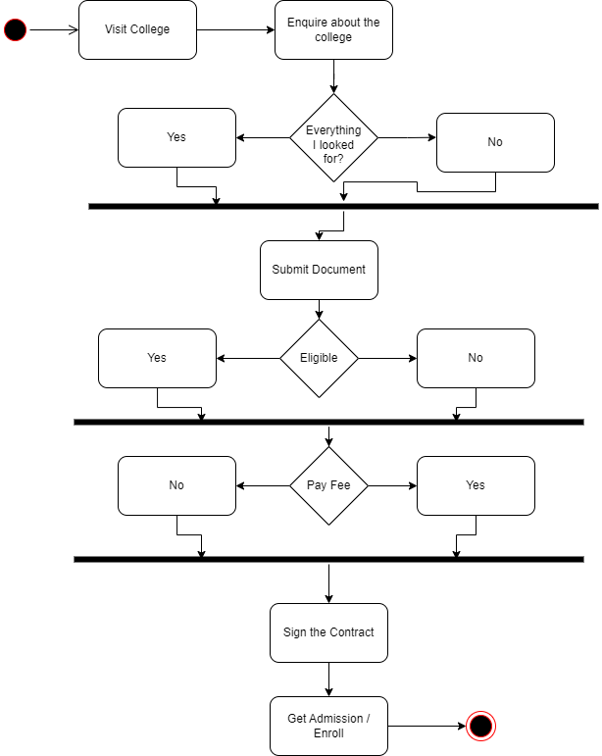

* 1. Consider the scenario of Order Processing. Once the order is received, the activities split into two parallel sets of activities. One side fills and sends the order while the other side handles the billing. On the Fill Order side, the method of delivery is decided conditionally. Depending on the condition either the Overnight Delivery activity or the Regular Delivery activity is performed. Finally, the parallel activities combine to close the order. With activity diagram, describes the processing of ordering.

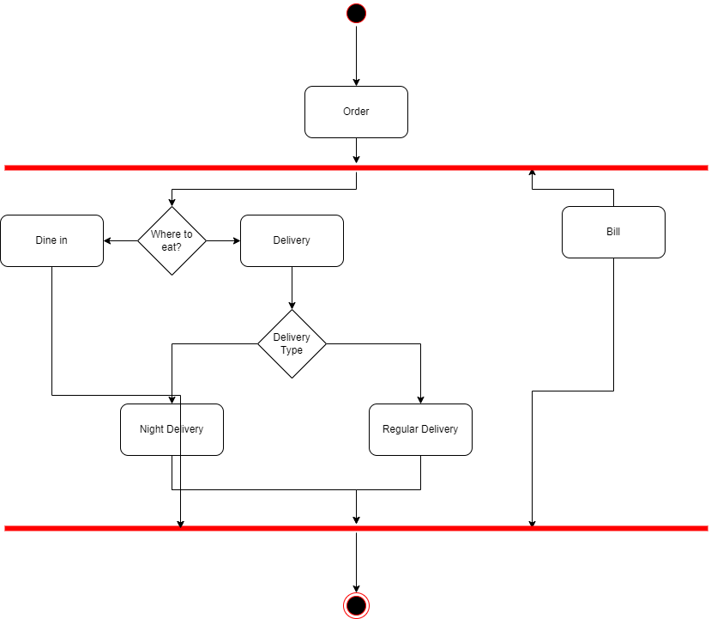

* 1. Show the flow of word processing application software with the help of activity diagram.

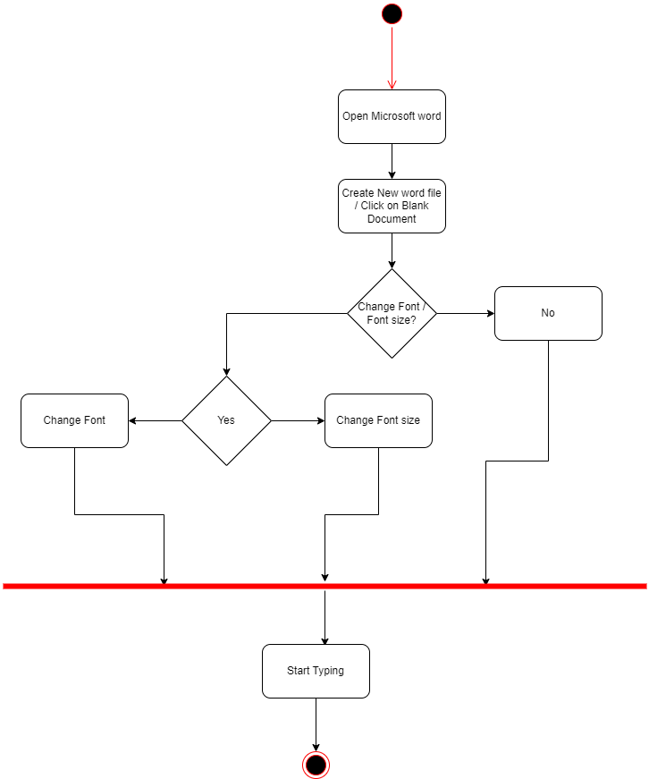

# Sequence Diagram

* 1. Consider a Library Management System. Using sequence diagram, show the interaction of objects in the system to perform the function ‘Create new library user accounts.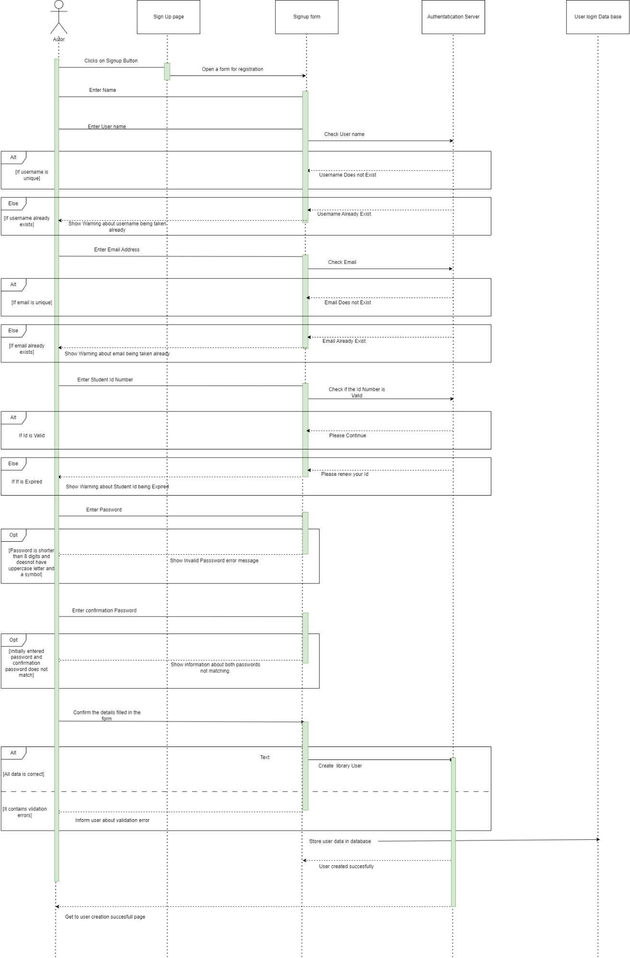
  2. In which sequence does the Online Exam System flow? Describes using sequence diagram.

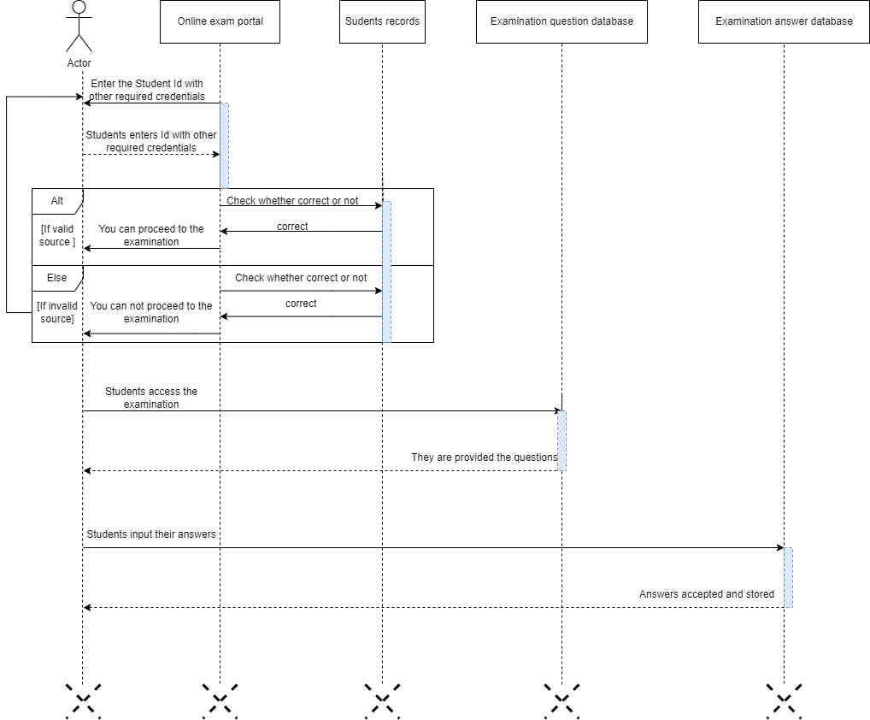

* 1. Represent the School Management System with sequence diagram.

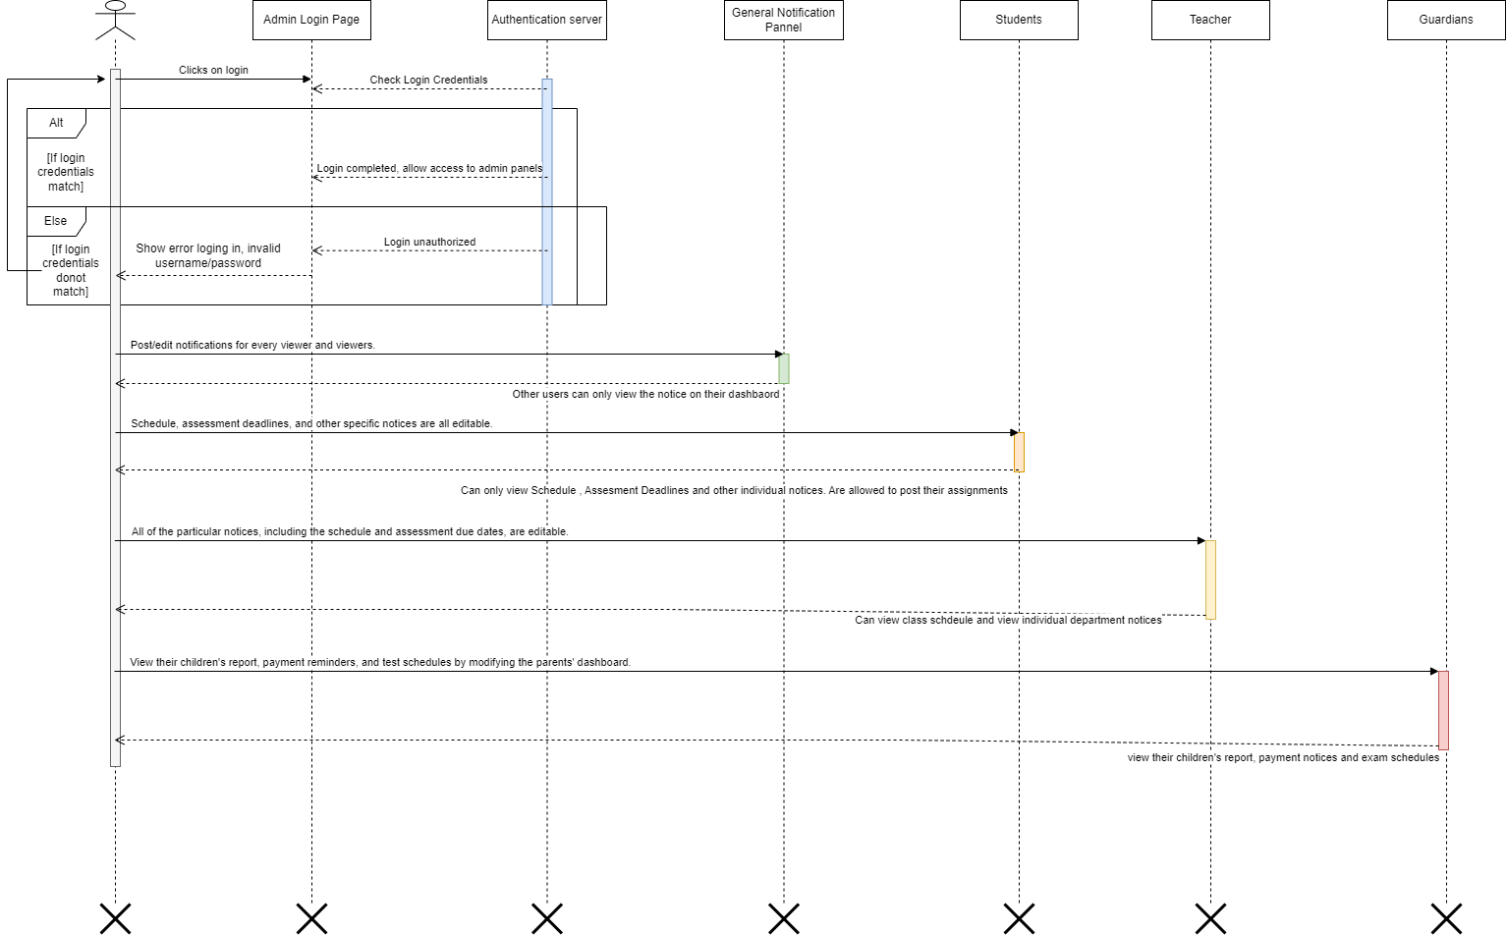

# Deployment Diagram

* 1. Show the necessary nodes, artifacts, associations and components required for Hospital Management System

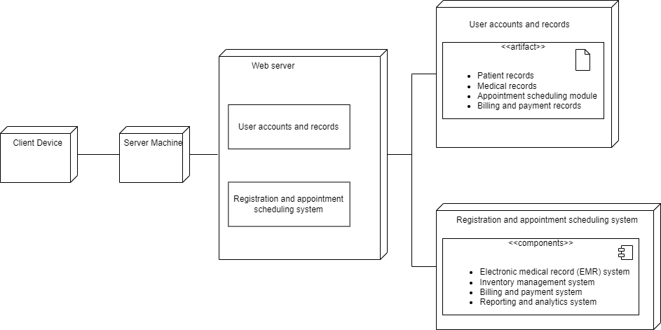

* 1. Draw a deployment diagram for Hotel Management System.

